10.79: a) 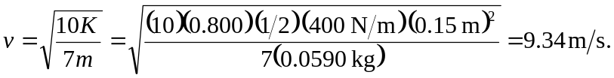

b) Twice the speed found in part (a), 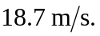 c) If the ball is rolling without slipping, the speed of a point at the bottom of the ball is zero. d) Rather than use the intermediate calculation of the speed, the fraction of the initial energy that was converted to gravitational potential energy is and solving for h gives 5.60 m.

